# LINarm++ Booster program deliverable

At the beginning of the program, a theoretical study of the principle of operation of a new type of variable stiffness actuator, a rough manual prototype and a preliminary design were available. The rough manual prototype allowed assessing the principle of operation of a curvilinear bending spring to modify the stiffness of a new variable stiffness actuator. Thanks to what was available before the beginning of the booster program, it was possible to assess the highlights of the actuator (energy-efficiency, compactness, decoupling of position and stiffness control, and infinite-turn rotation).

Thanks to the booster program, it was possible to manufacture, assemble and assess a completely functional new variable stiffness actuator, namely CS-VSA (Figure 1). Moreover, after an analysis of the state of the art and of public patents, a new patent application about the principle of actuation of the new actuator has been filled [1]. In order to assess the actuator within a real application, the new device has been embedded in a new version of the rehabilitation device developed within the experiment LINarm++ (Figure 2). The new CS-VSA actuator allowed overcoming the reliability issues that were present in the previous variable stiffness actuation architecture, namely LinWWC-VSA [2].

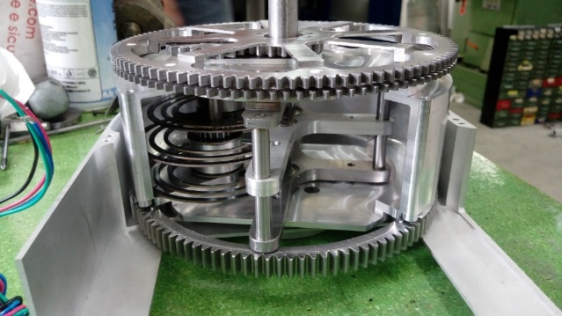 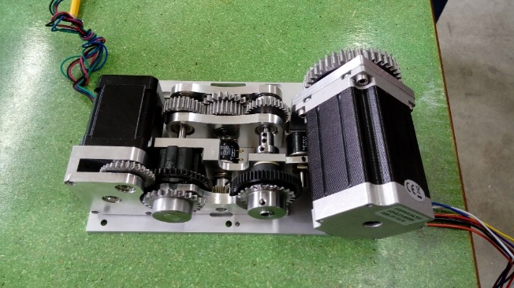

Figure 1 - Elastic mechanism of the CS-VSA (left). Actuation part of the CS-VSA (right).

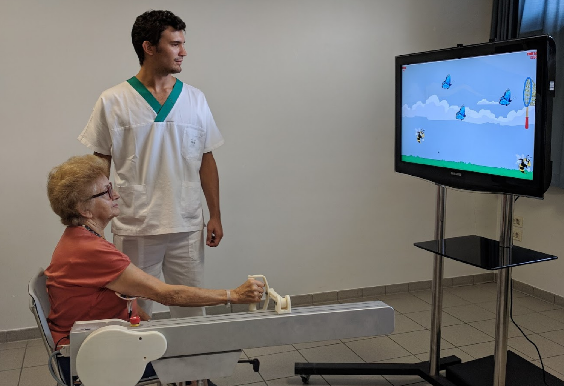

*Figure 2 - The new LINarm device embedding the new actuator CS-VSA.*

Thanks to the booster program, in parallel to the technical developments, i3p (Incubator of Innovative Companies of the Politechnic of Turin) carried out a support activity to approach the market. The program consisted in services aimed at achieving specific targets to meet the needs that typically arise in the first periods of life of a company. i3p organized for the team a course specifically addressed to deal with aspects related to the foundation of a startup and the creation of a business. The assistance in developing a Business Model Canvas, together with a training to formalize a customer discovery plan, to perform financial planning, and to develop a marketing plan was very useful for the team. The team, made up only of researchers without any managerial background, had the opportunity to acquire instruments and earn experience to approach the market.

The participation to the Booster program allowed the proponents to show their product in international exhibitions and conferences. In June 2018 the team presented the new version of the LINarm device, equipped with the CS-VSA actuator, at AUTOMATICA 2018 (Munich) where it was possible to probe the interest of companies operating in the robotics and automation sector about the CS-VSA solution. In October 2018 the team attended to the IROS 2018 conference (Madrid). During the conference, the CS-VSA entrepreneurial team discussed with researchers of other institutions and universities, focusing on the main issues to be improved, by collecting suggestions and observations. Finally, during the participation in MEDICA 2018 (Dusseldorf), the world’s largest event for the medical sector, it was possible to show the new LINarm device (embedding the CS-VSA actuator) to personnel working in the medical / rehabilitation sector.

In conclusion, the booster program allowed the team to get nearer and nearer to the market, overcoming what is typically achieved by research institutes within research projects. The team has become even more aware of the difficulties related to the creation and management of business. The assistance provided by the incubator i3p has certainly contributed substantially to train the team and to provide various managerial tools. The developed device is not yet on the market because some aspects has still to be properly engineered, to lower production costs, weights and dimensions, but the team is continuously working to continue on the taken path.

1. M. Malosio, L. Molinari Tosatti, A. Prini, “Giunto rotativo a rigidezza regolabile,” Patent Request 102018000006209, 11/06/2018.
2. G. Spagnuolo, M. Malosio, T. Dinon, L. M. Tosatti, and G. Legnani, “Analysis and synthesis of linwwc-vsa, a variable stiffness actuator for linear motion,” Mechanism and Machine Theory, vol. 110, pp. 85 – 99, 2017.