

Report for experiment MOTORE++   
Reporting period 2 (1.1. - 30.6.2015)

*A new Rehabilitation Robot for the upper limb: refinement and experimental trials*

_____________________________________________________________

Giovanni Cappiello (Humanware Srl)

Giancarlo Teti (Robotech Srl)

Carlo Alberto Avizzano (Fabrica 136)

**Version 1**

**Submission date: 05.08.2015**

**Use the table below as an internal changelog. You can delete it before submitting.**



|  |  |  |
| --- | --- | --- |
| **Date** | **Name** | **Changes/Comments** |
| 05.08.2015 |  |  |
|  |  |  |

# General remarks

*Please write the texts in the sections and keep everything short and concise. In case of charts, tables, pictures or other graphical material with higher resolution, please provide the original files as email-attachments or download links*

Nothing to mention

# Publishable Summary

*Please shortly summarize your project, its main objectives and intended outcome Please also briefly share the most important achievements of the reporting period with us. Please write this part of your report in a marketing-orientated manner, as the publishable summary can be used by the EU Commission for dissemination activities*. Please do not reveal information which might compromise your IP (e.g. planned patent application).

*[length: 8-10 lines and one media-friendly image/drawing, if possible]*

The goal is to develop a rehabilitation robot named MOTORE++ aimed to restore upper limb functionality in patients with neurological diseases and to assess his performance. This is a new haptic portable device, the first suitable for home based rehabilitation. Starting from a prototype developed in the last years, the project aims at delivering a small omnidirectional robot moving on transwheel, interacting with a patient providing assistance and force feedback during rehabilitation sessions. The software will allow to select among several exercises. Biomechanical studies of the interaction with the robot and on the arm impedance during exercises will be part of the Echord experiment.

During the first six months the device will be completely redesigned in order to achieve better performance and be ready for a CE certification process and an easy maintenance.

# Work progress

*Summarize in more detail the progress made towards reaching the objectives in the respective reporting period highlight clearly significant results and the actual status of your experiment. This part of the report is not intended for public use, but will be distributed to all experimenting partners involved in ECHORD++. Pleae keep this part short, ideally short description of the progress and the status and images, drawings, etc. with meaningful and self-contained captions.*

*[length: ½- 1 page of text, max. 2 pages in total including images etc.]*

As mentioned above, during the first six months the robot underwent trough a redesign process in order to. endow the robot with: (1) a new motherboard and a new CPU to achieve better performance, (2) a SD card and an USB port for data transfer, firmware upgrade and debugging, (3) a Wi Fi module replacing the Bluetooth module for a more stable connection to the PC, (4) a coulomb counter in the battery pack, (5) a new sump suitable for CE the safety issues related to the CE certification and an easy maintenance of the device.

From a mechanical point of view the changes can be seen in the pictures below

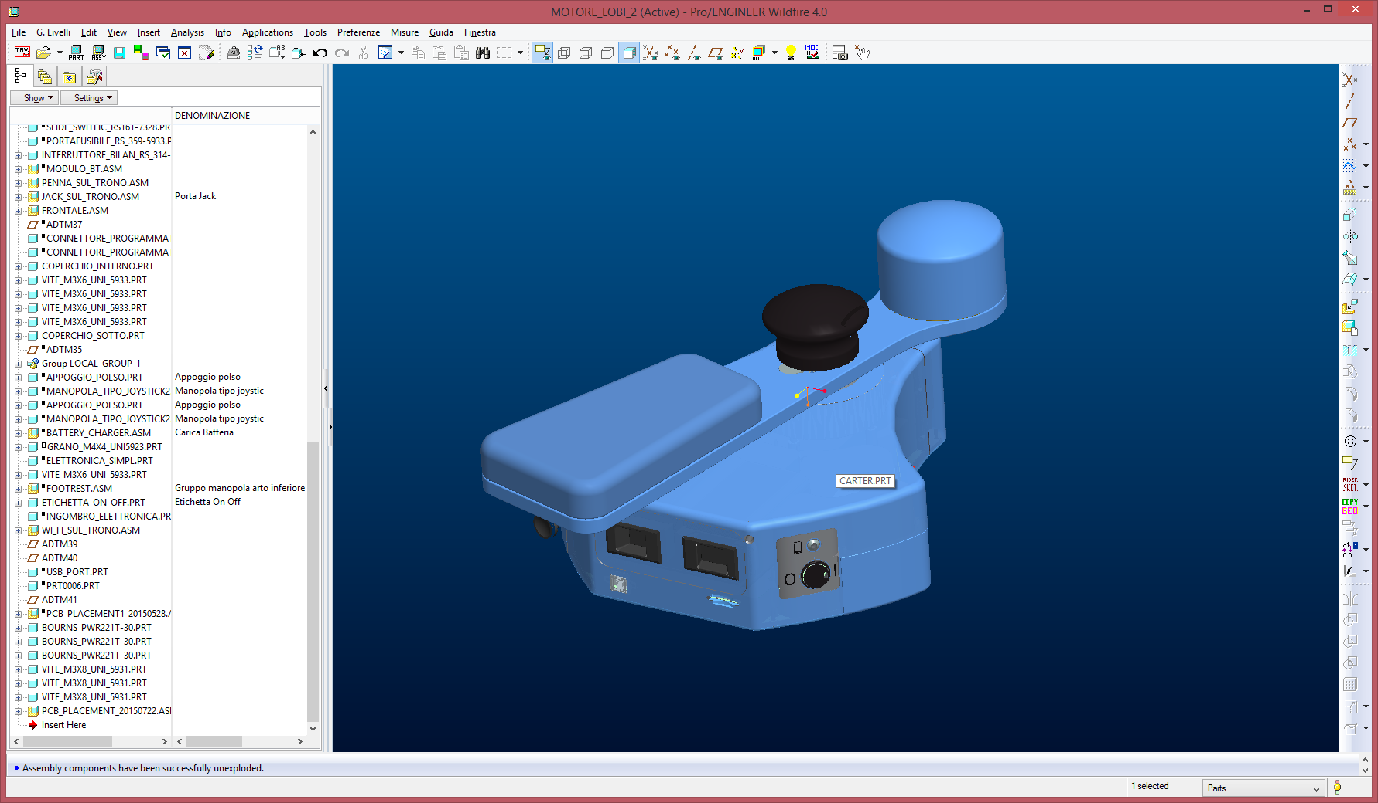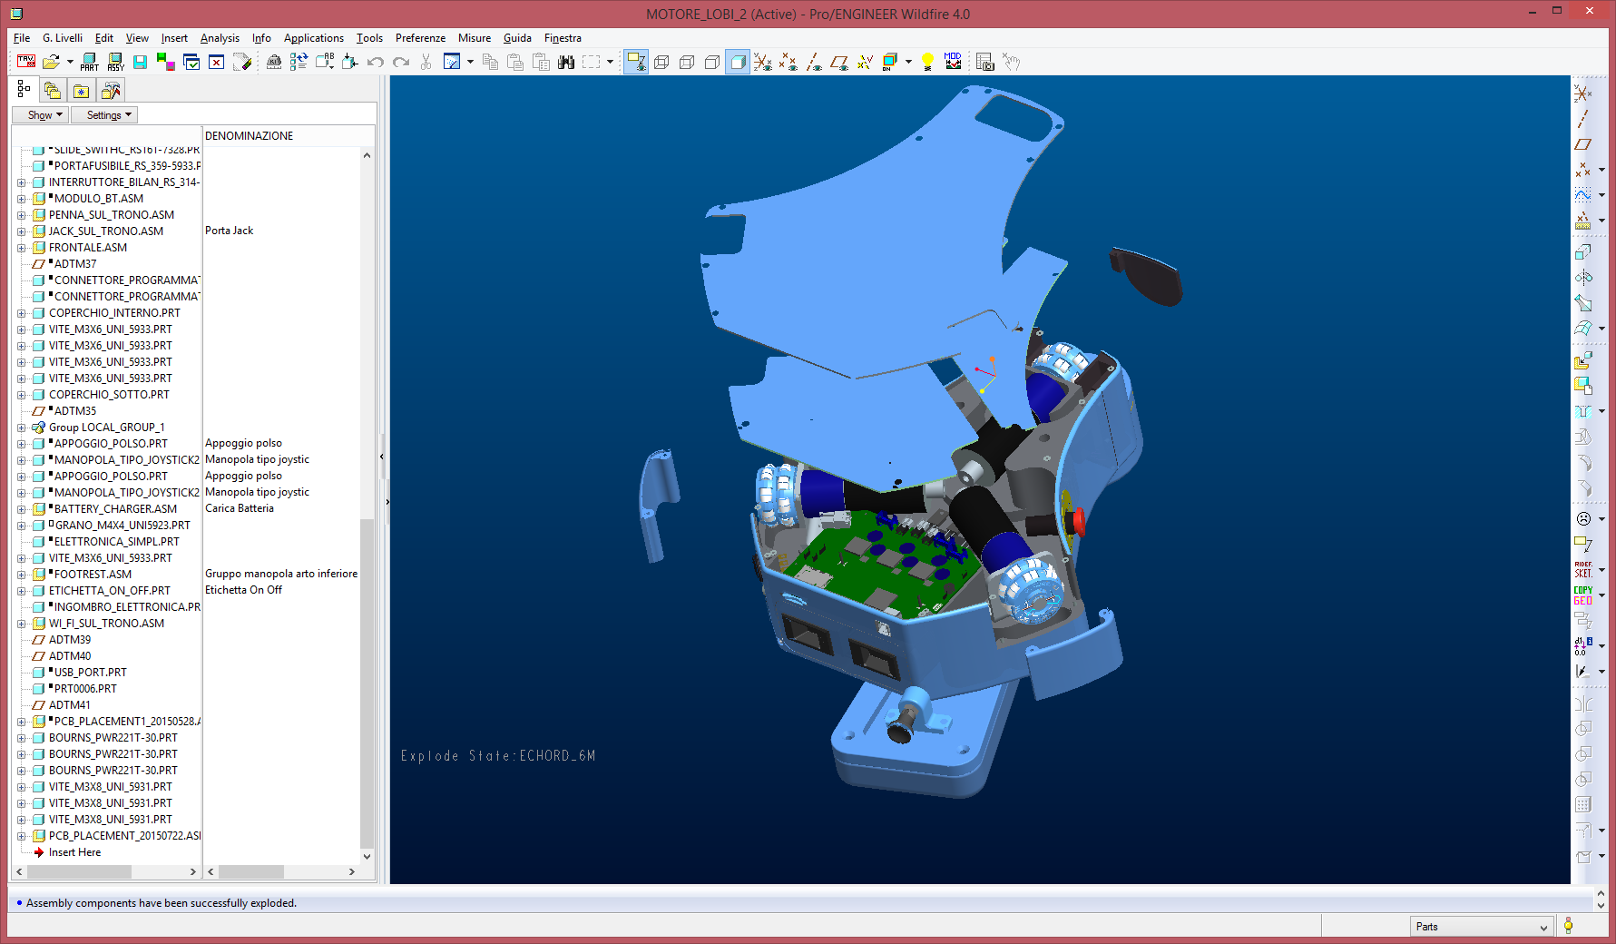

*Fig.1 the new design of the robot*

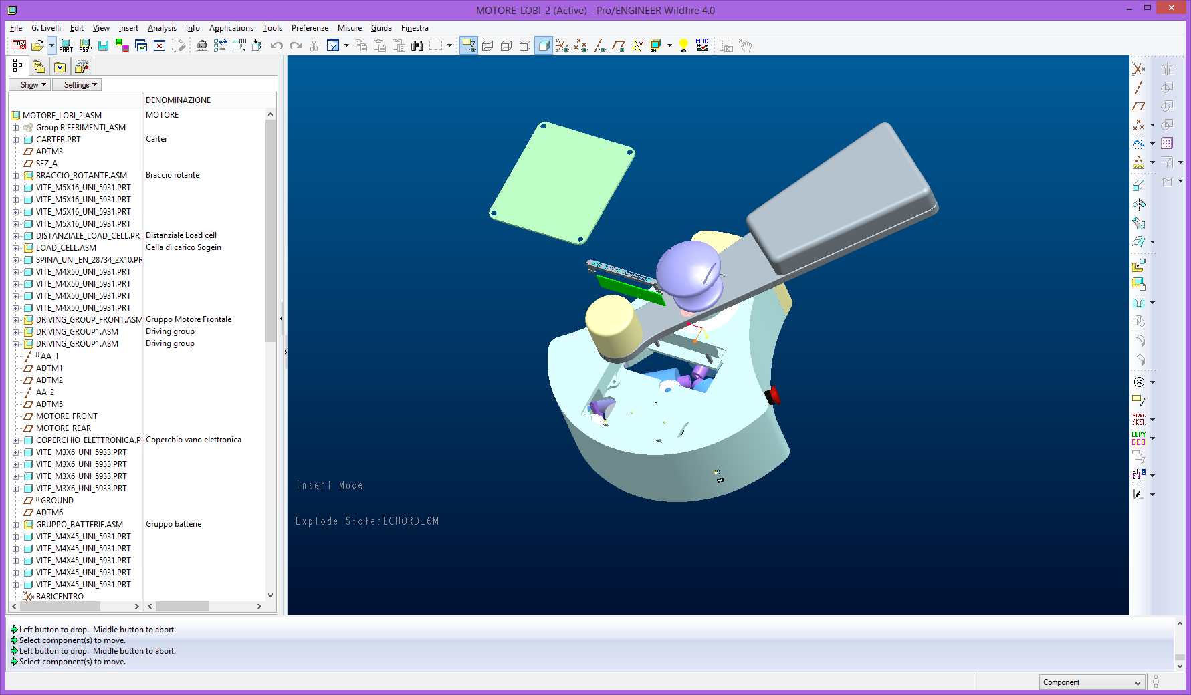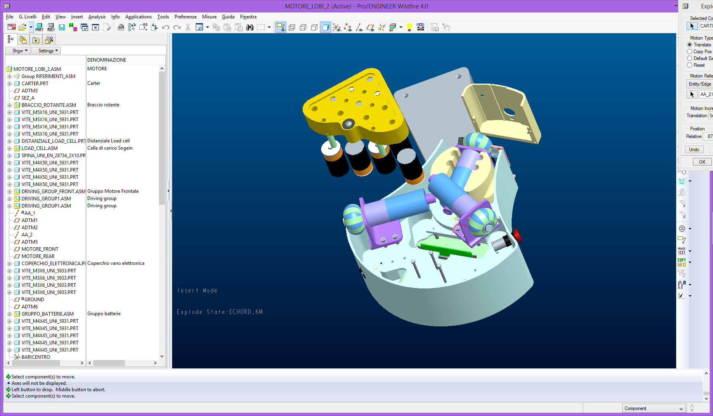

*Fig.2 the old design of the robot*

The new electronic board has been moved and it is now protected by a inner cover, as well as all the cabling. The wheels can be easier changed removing the external cover and the wheel doors. Also the battery pack has been redesigned and it is has more safe spring loaded contacts. The interior of the sump has been modified in order to support all the new component mentioned above.

The electronics of the system has been completely redesigned in order to add new sensors and IO devices, improve performances, reduce electrical noise, and rationalize the wiring. The new electronics consists of two boards: the main board or motherboard and the Wi Fi board. In the reporting period the two boards have been designed, the components selected and the schematics completed: the routing and the realization of PCBs is ongoing.

The new motherboard is based on the more powerful STM32F746ZGT6 microcontroller (ARM Cortex-M7, 216Mhz, RAM 320KB, Flash 1024KB, 144 pin) by ST Microelectronics and includes, as additional devices with respect to the old motherboard, a SD card for saving exercise data and USB for data transfer. Motor drivers (now VNH5019A) and accelerometer (now LIS302DL) have been updated. Additional current sensor for measuring motor currents and resistors on the motor control signals to avoid ringing and reduce electrical noise have been added. The Anoto digital pen, which was Bluetooth connected in the previous version, is now directly connected on a serial port. Furthermore, the electronics related to robot sensors and devices such as encoders, load cell, led, emergency buttons, etc. has been revised and updated in order improve robustness. Finally, the Wi Fi module has been separated from the motherboard in order to be mounted out of the robot metallic case and to make the system modular keeping the possibility of using Bluetooth for wireless communication. The schematic of new motherboard and Wi Fi board is attached to this document.

A new architecture based on the emerging Cortex M4F M7F has been defined. These microcontrollers offer on the side of a standard ARM architecture, better per-formances, full implemented floating point, portability and free development tool-chains, and access to byte, half-word and word in a natural fashion.

The implementation of a driver strategy based on DMA support allow the present ar-chitecture to overcome the existing message limitation based on the natural FIFO of the standard TMS320 architecture used for previous release of MOTORE.

The schematic of new motherboard and Wi Fi board is shown in the following pictures.

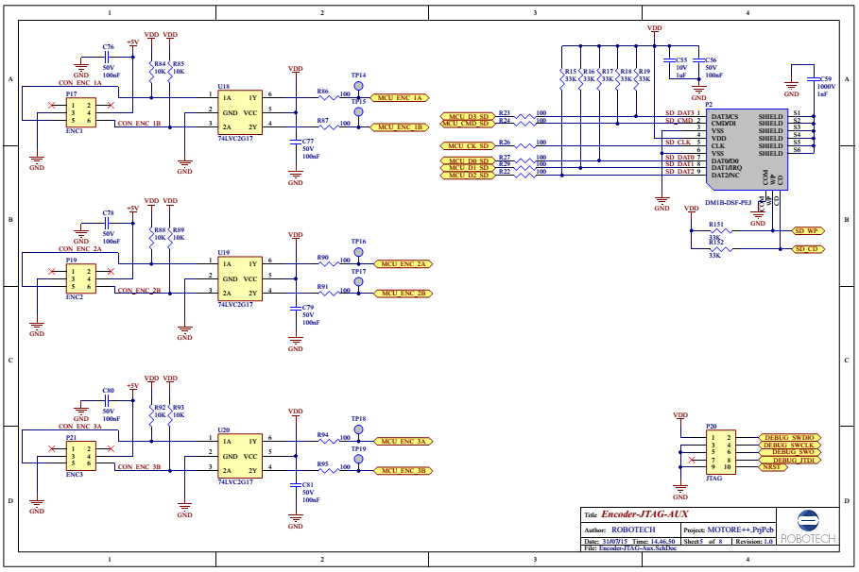

*Fig.3 the new electronic motherboard*

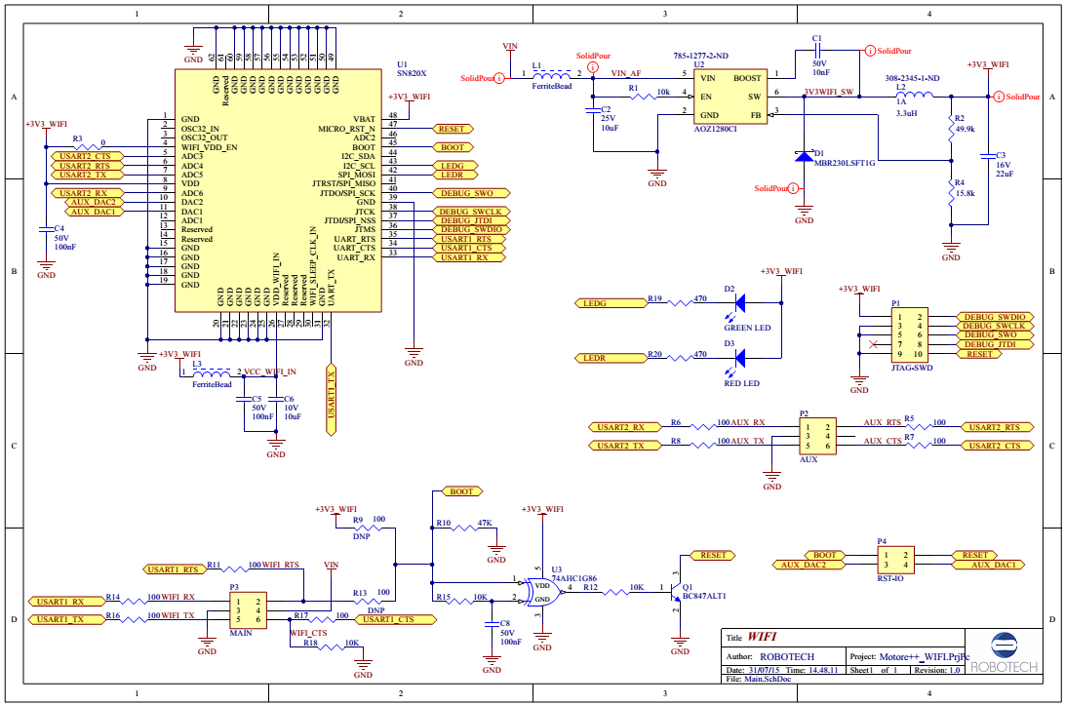

*Fig.4 the new wi-fi PCB*

# Deliverables, ‘Milestones, progress towards achievment of KPIs

*Fill in the tables below.Please mention only deliveralble, milestones etc. relevant for the period.*

*[length: depending on number of table entries.]*

***Deliverables***

|  |  |  |  |  |  |  |  |  |
| --- | --- | --- | --- | --- | --- | --- | --- | --- |
| **Number** | **Name** | **Task no.** | **Nature** | **Dissemination Level** | **Start** | **Due** | **Status** | **Comments** |
| *TR2* | *Monthly report* | *1* | *R* | *RE* | *M1* | *M6* | *Done* | *NA* |
|  |  |  |  |  |  |  |  |  |
|  |  |  |  |  |  |  |  |  |

***Milestones***

|  |  |  |  |  |  |
| --- | --- | --- | --- | --- | --- |
| **Number** | **Name** | **Tasks no.** | **Due** | **Status** | **Comments regarding verification** |
| *NA* | *NA* |  |  |  |  |
|  |  |  |  |  |  |
|  |  |  |  |  |  |

***Progress towards technical KPIs***

|  |  |  |  |  |  |
| --- | --- | --- | --- | --- | --- |
| **Number** | **Name** | **Tasks no.** | **Due** | **Status** | **Comments regarding verification** |
| 1 | Start: NiMh Battery 10Ah not swappable (efficiency drops at 50% after 6 months)  End: Li-Ion battery 10Ah swappable | 1 | M2 | *Done* | *Can be seen in picture, photos and working in the current intermediate prototype* |
| 2 | Start: The robot exerts 15N (for higher interaction forces the wheels slip)  End: The robot will exert at least 30N | 1 | 4 | *Done* | *Can be seen working in the current intermediate prototype (and measured by the load cell)* |
| 3 | Start: Optical position sensor (Anoto DP201 Bluetooth with communication issues)  End: Anoto DP 103 wired with rotation information | 1 | 4 | *Done* | *Can be seen implemented in the current intermediate prototype* |
| 4 | Start: CPU Texas Instruments f28335 150Mhz  End: Cortex M7 180MHz 9150 | 1 | 6 | *Done* | *Can be seen in the drawings of the next prototype (we are currently machining this new version)* |
| 5 | Start: No on-board storage  End: SD card slot on board | 1 | 8 | *Done* | *Can be seen in the drawings of the next prototype (we are currently machining this new version)* |
| 6 | Start: 2 rehabilitation games  End: 4 games implemented in the prototype | 2 | 6 | Done | *Can be seen implemented in the current intermediate prototype* |

***Progress towards impact-related KPIs***

|  |  |  |  |  |  |
| --- | --- | --- | --- | --- | --- |
| **Number** | **Name** | **Tasks no.** | **Due** | **Status** | **Comments regarding verification** |
| *NA* | *NA* |  |  |  |  |
|  |  |  |  |  |  |
|  |  |  |  |  |  |

***Dissemination activities***

|  |  |  |  |  |  |
| --- | --- | --- | --- | --- | --- |
| **Number** | **Name** | **Tasks no.** | **Due** | **Status** | **Comments, especially references, links, … Please send images, videos, press material, etc. in the mail or give a download link** |
| *NA* | *NA* |  |  |  |  |
|  |  |  |  |  |  |
|  |  |  |  |  |  |

# Deviations & Reasons

*Finally, please indicate any deviations from the DoW of your experiment (including deviations concerning staff efforts) and a short explanation for these, if any. You can refer to the tables in section 3.*

*[length: as short as possible, bullet-style format]*

*Nothing to mention*