MODUL

Partners:

ETH Zurich



CDD Ltd.

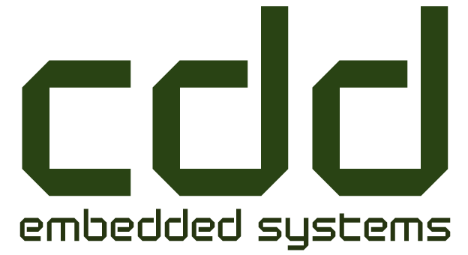

**Final Report**

Table of contents

Section 1: Executive summary 3

**Section 1.1: Milestone overview** 4

**Section 1.2: Deliverable overview** 4

**Section 1.3: Technical KPIs** 5

**Section 1.4: Impact KPIs** 5

**Section 1.5: Dissemination KPIs** 6

**Section 1.6: Additional achievements** 6

Section 2: Detailed description 6

Section 2.1: Scientific and technological progress: 6

**Section 2.2: Scientific and technological achievements** 7

**Section 2.3: Socio-economic achievements** 8

**Section 2.4: Dissemination activities** 8

Section 3: Resource usage summary: 9

Section 4: Deviations and mitigation 9

Section 5: Future work: 10

Section 6: Lessons learned (optional) 10

**Section 1: Executive summary**

* The goal of the project was to build a fully integrated series elastic actuator module that is robust and force controllable. This robot joint is integrated in a quadrupedal walking robot enabling it to dynamically walk and overcome challenging terrain.
* Available actuators as used in traditional industrial robots are stiff and position controllable. They cannot be used in robots that are supposed to interact with their environment.
* To overcome this deficiency, we build a single module, ANYdrive, with tightly integrated motors, gears, springs, electronics and controls. ANYdrives can be simply connected and integrated to robotic systems such as collaborative robot arms, legged robots, exoskeletons or rehabilitation devices. The functionality of the system is demonstrated in the quadrupedal robot ANYmal.
* By providing a solution for the emerging market of robots interacting with their environment, we enable different groups from research labs, over engineering companies, to large scale robot manufacturer to build robots with relatively little effort.
* After being able to demonstrate an outstanding performance of ANYdrive we get an increasing number of requests. Therefore, ETH is creating a spin-off company to sell the drives beginning of next year. Thanks to MODUL, the group could secure financial support for the comping years in order to further improve ANYdrive, to bring it to market, and to explore different applications such as the legged robot ANYmal.

**Section 1.1: Milestone overview**

|  |  |  |
| --- | --- | --- |
| (# | Description | status |
| M1 | Motor control electronics completed | Timely achieved |
| M2 | Power management board designed and developed | Timely achieved |
| M3 | Motor control electronics integrated into enhanced SEA module | Timely achieved |
| M4 | Final demonstration of the fully integrated robot | Timely achieved |

**Section 1.2: Deliverable overview**

|  |  |  |
| --- | --- | --- |
| # | Description | status |
| D2.1 | Motor control electronics - Requirement specification for CDD | Timely submitted |
| D3.1 | SEA module - Design description | Timely submitted |
| D3.2 | Fully working SEA module with integrated electronics | Timely submitted |
| D3.3 | SEA module - Operator's manual (including technical descriptions, illustrations, application notes and performance tests) | Deviated |
| D4.1 | Power management - Requirement specifications for CDD | Timely submitted |
| D5.1 | Working legged robot with 12 integrated SEA modules and the power and control electronics | Timely submitted |
| D5.2 | Legged platform – Report (containing specifications, technical illustrations, photos performance tests) | Timely submitted |
|  | RIF Report | Not submitted |
|  | Story Board | Timely submitted |
|  | Multi-Media Report | Timely submitted |

* D3.3: A product flyer was publically released but a detailed technical description as provided to ECHORD is only available upon request. Performance tests are published in [1]
* No RIF was visited (see explanation in Section 4)

**Section 1.3: Technical KPIs**

|  |  |  |
| --- | --- | --- |
| # | Description | status |
| 120 | Experimental data, Publications, CAD drawings | Timely achieved |
| 2 | Failure detection, identification and recovery | Achieved |
| 1 | Ingress protection rating | Achieved |
| 5 | Performance - Power | Deviated |
| 4 | Performance - Speed | Deviated |
| 3 | Performance - Torque | Achieved |
| 6 | Performance – Control loop execution | Achieved |
| L4 | Performance – Max. joint speed | Deviated |
| L5 | Performance – Max. translational speed | Deviated |
| L6 | Performance – Obstacle negotiation capabilities | Achieved |
| L3 | Performance – Range of joint motion | Achieved |
| L7 | Recovery manoeuvers | Achieved |

* 5,4,L4: the supply voltage of ANYdrive was reduced to 48V due to safety reasons (c.f. 96V in proposal). The developed electronics however can take up to 100V which would lead to double the speed .
* L5: Maximal translational speed is still under improvement. A published value in [1] is 0.8m/s.

**Section 1.4: Impact KPIs**

|  |  |  |
| --- | --- | --- |
| # | Description | status |
| 1 | New jobs: Creation of spin- off company for SEA modules and general purpose legged robot | Achieved |
| 2 | Revenue generated with SEA module (General purpose SEA module) | Expected in Q1 2017 |
| 3 | Revenue generated with full legged robot ((semi) autonomous legged robot) | Expected in Q2 2017 |
| 4 | Revenue generated with customer service and consulting (Basis for customization of the legged platform) | Expected in Q2 2017 |

* 2: product will be launched in Q1 2017, several requests are already existing
* 3: early customer versions will be delivered to selected research labs (Edinburgh, Poznan, CMU)
* 4: customer service packages are part of the early adopter program of ANYmal

**Section 1.5: Dissemination KPIs**

|  |  |  |
| --- | --- | --- |
| # | Description | status |
| 4 | Video (e.g. Youtube) | Achieved |
| 2 | Website | Achieved |
| 7 | Coverage in local & national press (Swiss daily print medias such as NZZ, Tagesanzeiger, 20min, Blick; international media channels such as robohub,Gizmodo, Wired, IEEE Spectrum Automaton; 15 | Achieved |
| 8 | International media (magazines such as Wired, Automation, Messtec drives automation and the Harmonic Drive customer magazine; various TV channels/programs) 15 | Achieved |
| 1 | Lab Tours | Achieved |
| 3 | Social Media (e.g. Facebook Page) | Achieved |
| 5 | Fairs (Automation & Elektronics, SINDEX, Automatica) | Achieved |
| 6 | Conference submission (e.g.ICRA, IROS, RSS, FSR, Humanoids and CLAWAR) | Achieved |

**Section 1.6: Additional (unplanned) achievements**

* Seed-funding for 3 years commercialization phase for ANYdrive and ANYmal ([www.wysszurich.uzh.ch/projects/anymotion/](http://www.wysszurich.uzh.ch/projects/anymotion/))
* Gebert Rüf Foundation Project to release a research platform ([www.grstiftung.ch/de/portfolio/projekte/alle/y_2016/GRS-008-16.html](http://www.grstiftung.ch/de/portfolio/projekte/alle/y_2016/GRS-008-16.html))
* Various Collaborations (Moog, HoCoMa, Hörbiger, Sonceboz, etc.)
* Several invitations to public events for presentations and demonstrations (e.g. Zurich.Minds 2015, Swiss-Innovation-Forum 2016, etc.)

**Section 2: Detailed description**

**Section 2.1: Scientific and technological progress**

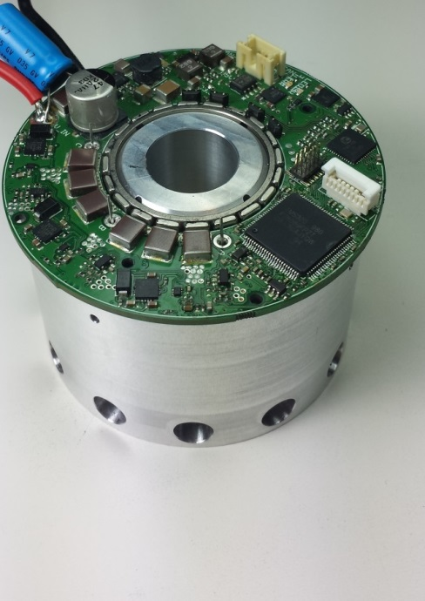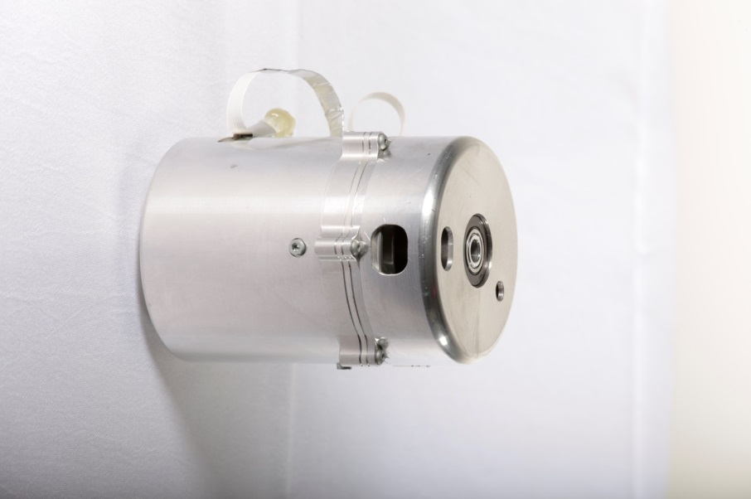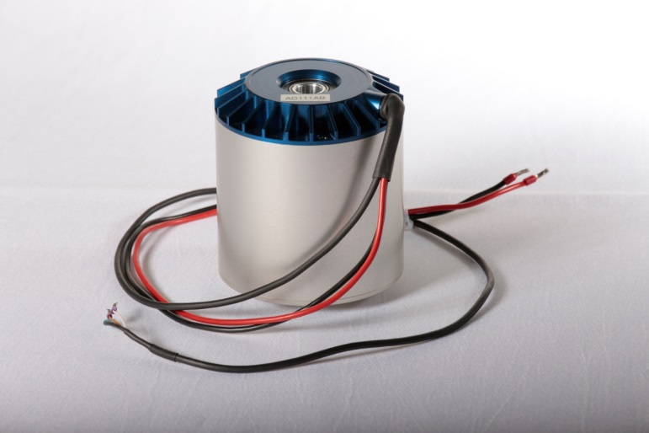

During the project MODUL, the consortium developed the actuator unit ANYdrive[1] and the quadruped ANYmal[2]. We made a step change by turning an existing demonstrator technology that was developed and tested at ETH Zurich over the last 7 years[3] into prototypes respectively early stage products that are ready to be used in real-world applications and can be distributed to first customers.

***ANYdrive*** is a modular robot joints for different machines such as legged robots or manipulators. During the development, ETH had the lead for mechanical design, firmware and control development, as well as integration and testing while CDD Ltd provided the embedded motor control electronics. During the course of the project, various CDD members joined ETH for extended periods of time in order for joint integration and testing. The consortium made several design iterations (in fact four versions of the electronics, three versions for the mechanics) from test-benches, over a first and second completely different prototype. The latest version was thoroughly and successfully evaluated over several months as testbench units and embedded in legged robots. By end of the project MODUL, we manufactured about 30 units of ANYdrives.

***ANYmal*** is a quadrupedal transporter built from the modular drive units ANYdrive. To this end, comparably simple mechanical links were designed to connect three joints per leg to a single mainbody containing all electronic components such as computer and batteries. In order to achieve high robustness for real-world applications, we put emphasize on sealing (water, dust) and fall protection. An onboard battery and power management system that can be centrally controlled from a touch panel mounted on the robot was designed and integrated by ETH.

**Section 2.2: Scientific and technological achievements**

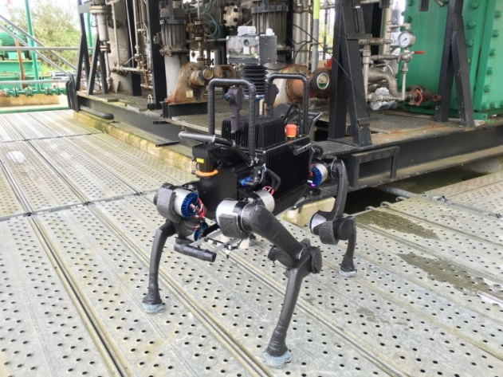

The performance of ANYdrive and ANYmal reached or exceeded the expectations. By end of the project MODUL, we have probably the worldwide most advanced compliant actuator and quadrupedal robot at hand.

***ANYdrive:*** The modular series elastic actuator unit underwent three iterations of the mechanics and four iterations of the integrated motor control electronics. The latest generation consists of high torque motors, harmonic drive gears, custom torsion spring, absolute position sensors, and motor control electronics embedded in a compact housing with hollow shaft. It could be successfully tested in different experiments and showed better performance measures than proposed. A detailed evaluation showing a superior performance compared to state of the art solutions is presented in [1]. In particular, ANYdrive features high impact robustness, fast motion tracking and low impedance yet high-bandwidth force controllability. A movie documentation of the actuator performance is available here: <https://youtu.be/lESsdD3o78k>. Researchers (mainly during lab visits) and industry (e.g. Automatica) were impressed by the performance of the system and expressed their interest to buy the units. Finally, we could also create a patent [2] for this product that will be exclusively licensed to the ETH spin-off company. Since a number of prototype units are already in use for and extend period of time, the project MODUL led to a TRL change from level 4 to 7.

***ANYmal:*** The quadrupedal robot is one of the first autonomous, outdoor capable (water, dust, and fall proof) legged machines. It is in use in two applications, one targeting the inspection of industrial sites ([www.argos-challenge.org](http://www.argos-challenge.org)), the other search and rescue robotics ([www.nccr-robotics.ch](http://www.nccr-robotics.ch)). With onboard batteries, computers and various sensors such as lasers, cameras, IMU etc., the robot is capable of conducting fully autonomous missions up to three hours. This could be demonstrated in different field experiments and particularly during the ARGOS competition, where our robot had to compete in missions on a test oil and gas rig under realistic conditions (outdoor, rain) against commercially available tracked vehicles. The machine made a step from TRL 4 to 6. Thanks to the ANYdrive joint, the quadruped is fully force controllable. Hence, state of the art whole body control algorithms can be applied to deal with unstructured environments. The machine can perform dynamic locomotion gaits and very complex maneuvers in order to overcome large obstacles. A selection of videos showing the performance of the system in action is available at [www.rsl.ethz.ch/robots-media/anymal](http://www.rsl.ethz.ch/robots-media/anymal) and a detailed system description is available at [1].

**Section 2.3: Socio-economic achievements**

The developed products ANYdrive and ANYmal seem of big interest for commercial application in different domains. In particular for the drive units we got requests from various customer segments as there are currently no devices of similar properties and performance available. It looks like the proposed product has the potential to establish as a valuable solution for robots that interact with their environment since the product combines safety with performance.

With the results, ETH Zurich could secure substantial funding for the coming years (e.g. Wyss Project ANYmotion [www.wysszurich.uzh.ch/projects/anymotion/](http://www.wysszurich.uzh.ch/projects/anymotion/)), and is currently creating a spin-off that makes the product commercially available (ANYbotics AG, [www.anybotics.com](http://www.anybotics.com)). Over the next 3 years, 8 people of our lab, backed up with an experienced industrial executive, will work full-time to build up a growing business.

Moreover, there has been extensive exchange between CDD and ETH Zurich that resulted in several temporary and one permanent exchange of researchers.

**Section 2.4: Dissemination activities**.

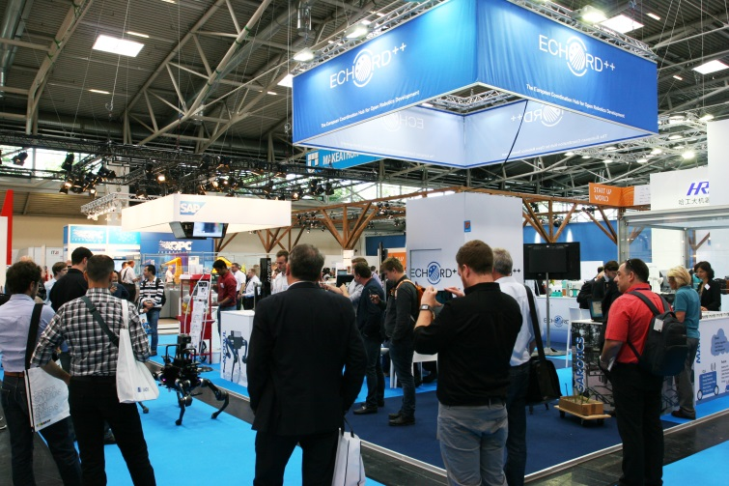Throughout the project MODUL, we had several dissemination activities. Almost every week, our technology was demonstrated to ETH visitors (companies, universities, school classes, etc). All movies are available on the youtube channel [www.youtube.com/leggedrobotics](http://www.youtube.com/leggedrobotics). News were announced through the twitter and facebook channel of the Robotic Systems Lab. Both products are illustrated in detail on the project specific homepages [www.rsl.ethz.ch/robots-media/anydrive](http://www.rsl.ethz.ch/robots-media/anydrive) and [www.rsl.ethz.ch/robots-media/anymal](http://www.rsl.ethz.ch/robots-media/anymal). The technology was published as an IROS contribution <http://e-collection.library.ethz.ch/view/eth:49454>. Furthermore, the project outcome is presented in different workshops such as e.g. <https://iros2016torquecontrolledactuation.wordpress.com/>. Several news presented our work (for a comprehensive list, see <https://www.facebook.com/rslethz/> and <http://www.rsl.ethz.ch/the-lab/news/2016.html>. Finally, we participated in different trade fairs such as Automatica and Sindex 2016.

**Section 3: Resource usage summary**

***Resource usage ETH***

The figures below are DRAFT, because

* The final figures are provided only after the official end of this period,
* The currency conversion will be defined only after the official end of the period. For this table the conversion of 1.08 has been used (1 EUR = 1.08 CHF),
* VAT is still in the prices
* Period 1 is already completed in NEF/EKAS, Period 2 works with unconfirmed figures

|  | **Category** | **Amount** | **Explanation** |
| --- | --- | --- | --- |
| **Period 1** | Personnel | 49,669 € | Cost of personnel for a total of 6.75 PMs (Engineer: Andreas Lauber, 6 PM (on Tasks 1, 2, 3, 6); Student assistant: Yves Zimmermann: 0.75 PM (on Task 3)) |
|  | Travel | 687 € | Dr. Höpflinger,Dr. Hutter; Echord Kickoff Meeting; Paris; 14.-16.1.15 |
|  | Consumables | 48 € | shipping costs |
|  |  | 194 € | Hardware consumables |
|  |  | 775 € | Components (validated components) |
|  |  | 3,840 € | Component parts (special springs) |
|  |  | 6,301 € | Software (ssCANopen, License) |
|  |  | 12,018 € | Components (motor kits) |
|  |  | 283 € | various components and semifinished goods for construction |
| **Period 2** | Personnel | *100,209 € | Cost of personnel for a total of 20.42 PMs (Engineer: Andres Lauber, 3 PM (on Tasks 5, 6, 7); PhD student: Vassilios Tsounis, 8 PM (on Tasks 4-7); Student assistant: Yves Zimmermann, 0.42 PM (on Task 3); Assistant: Joanthan Chan, 9 PM (on Tasks 3, 5, 6)) 0.75 PM (on Task 3) |
|  | Travel | *679 € | Prof. Hutter; Echord++ Review;Lissabon; 19.10.15 |
|  |  | *306 € | J. Chan; misc. train tickets |
|  |  | *24 € | Dr. Höpflinger, Dr. Hutter; Echord Kickoff Meeting; Paris; 14.-16.1.15 |
|  | Consumables | *88 € | Software |
|  |  | *433 € | Interface |
|  |  | *112 € | shipping costs |
|  |  |  |  |
| **Total** | Personnel | *149,878 € |  |
|  | Travel | *1,017 € |  |
|  | Consumables | *24,092 € |  |
|  | **Total dir.costs** | **\*174,987€** |  |

* ) unconfirmed figures

**Section 4: Deviations and mitigation**

There are no major differences to the proposal except for substantial internal redistribution of the work load. Instead of CDD, ETH developed the battery and power management system using third party funding sources. This allowed CDD to concentrate on the motor control electronics development. Furthermore, most of the current firmware was developed by ETH.

The only spec that slightly diverges from the initial proposal is the joint voltage and hence peak velocity and power. While the system is designed to handle up to 96V, it is currently only operated at about 50V due to safety reasons.

The consortium initially planned to conduct a RIF visit in Bristol, which was cancelled due to several reasons. First and foremost, the project around ANYdrive and ANYmal has grown over the last years to currently 12 researchers that work with the same robot on a daily basis. A move to RIF would have significantly reduced the overall productivity. Moreover, ETH could build up large facilities including indoor and outdoor testing areas and various sensors for performance evaluation such that there was no expected profit from the infrastructure at Bristol. Hence, we decided to skip the RIF visit but to host extended integration weeks with all partners at ETH Zurich (several of them were financially covered by 3rd party funding of ETH).

**Section 5: Future work**

ETH Zurich could secure financial support to finally bring the prototypes developed in MODUL to commercial products. As part of the Wyss-Translational-Center in Zurich, ANYdrive and ANYmal will be further developed for use in different robot applications. All products will be brought to market by ANYbotics AG, a spin-off company of ETH Zurich that is founded by 8 ETH employees. We expect that the first ANYdrive systems can be sold to customers early 2017 after a final iteration. The team could already establish a number of potential customers building collaborative robot arms, mobile platforms, rehabilitation device, as well as several research institutes creating robotic systems. While first product variations are already work in progress, the complete drive solution will be scaled upon customer’s needs.

1. [www.rsl.ethz.ch/robots-media/anydrive](http://www.rsl.ethz.ch/robots-media/anydrive)
2. [www.rsl.ethz.ch/robots-media/anymal](http://www.rsl.ethz.ch/robots-media/anymal)
3. [www.rsl.ethz.ch/robots-media/starleth](http://www.rsl.ethz.ch/robots-media/starleth)