

**STRAUSS**



**CWS**



**UniHB**

[Universität Bremen](http://www.uni-bremen.de/) 

**Final Report**

Table of contents

Section 1: Executive summary 3

Section 1.1: Milestone overview 3

Section 1.2: Deliverable overview 4

Section 1.3: Technical KPIs 4

Section 1.4: Impact KPIs 4

Section 1.5: Dissemination KPIs 4

Section 1.6: Additional achievements 5

Section 2: Detailed description 5

Section 2.1: Scientific and technological progress: 5

Section 2.2: Scientific and technological achievements 5

Section 2.3: Socio-economic achievements 5

Section 2.4: Dissemination activities 5

Section 3: Resource usage summary: 5

Section 4: Deviations and mitigation 5

Section 5: Future work: 5

Section 6: Lessons learned (optional) 5

**Section 1: Executive summary**

Keep things short and simple here. The text should precisely and concisely answer to the following questions (see examples)

* What was the goal of the project?

The goal of the experiment was to improve the previously developed asparagus detection system and the robotic harvesting tool.

* Why the solution to the problem was important?

At the end of the AmLight project (starting point of GARotics) the detection rate as well as the harvesting success rate were far too low (< 70%) for commercial use. What was proposed as a solution?

The proposed solution was a combination of (i) the implementation of the latest stereo camera, (ii) tracking of detected stalks and (iii) the introduction of an active harvesting tool.

* What was proposed as an impact of your solution?

The aim within GARotics was to reach an asparagus detection rate of 98% of which 95% should have been harvested successful.

* What is the final impact at the end of the project and what are the deviations in achieving the impact?

The asparagus detection rate was above 90%. The harvesting success for the first harvesting tool reached 90%. However, as the tracking of stalk back to the second harvesting tool was not developed for field tests it reached only a success rate of 85%.

**Section 1.1: Dissemination milestone overview**

|  |  |  |
| --- | --- | --- |
| # | Description | status |
| M1 | Video | Achieved |
| M2 | Flyers, posters, roll-ups | Timely achieved |
| M3 | RIF experiment demonstration | Achieved |
| M4 | Exhibitions (e.g Agritechnica, expoSE) | Timely achieved |
| M5 | Press coverage (e.g. Der Erdbeer und Spargelprofi, Agrartechnik, Vida Rural, Alimentación Equipos y Tecnologia) | Timely achieved |
| M6 | experiment website | Timely achieved |

**Section 1.2: Deliverable overview**

|  |  |  |
| --- | --- | --- |
| # | Description | status |
| RIF | Report on RIF visit outcome | submitted |
| D1.1 | Implementation report | Timely submitted |
| D3.1 | Field experiment report (first season) | Timely submitted |
| D3.2 | Field experiment report (second season) | Timely submitted |
| D4.1 | GARotics exploitation plan | Timely submitted |
| SB | Story Board | submitted |
| MMR | Multi-Media Report | Timely submitted |

**Section 1.3: Technical KPIs**

|  |  |  |
| --- | --- | --- |
| # | Description | status |
| 1 | Increase of detection rate for individual stalks | Timely achieved |
| 2 | Harvesting performance (including speed) | Achieved |
| 3 | Forecast quality | Achieved |
| 4 | Operation of a redundant system | Deviated |

**Section 1.4: Impact KPIs**

|  |  |  |
| --- | --- | --- |
| # | Description | status |
| 1 | Competitive production costs | Achieved |
| 2 | Increasing competitiveness of European machine manufacturers | Achieved |
| 3 | Scalability of results | Achieved |

**Section 1.5: Dissemination KPIs (see above – wording not clear)**

|  |  |  |
| --- | --- | --- |
| # | Description | status |
| 1 |  | Not Achieved |
| 2 |  | Not Achieved |

**Section 1.6: Additional (unplanned) achievements**

* none

**Section 2: Detailed description**

**Section 2.1: Scientific and technological progress**

The GARotics experiment was divided into four tasks closely linked together.

**Task 1** had the aim had the aim to implement technological solutions to the green asparagus harvesting machine. The main focus here was the development of an improved green asparagus **detection system** and the development of an **active harvesting tool**.

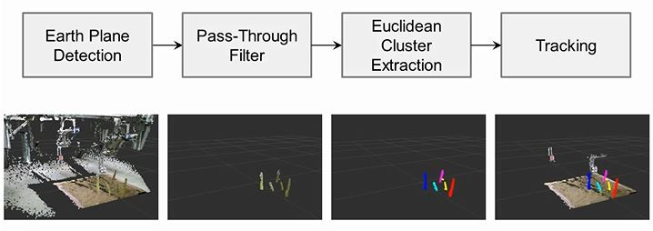The core of the **detection system** was the introduction of a Kinect v2 stereo camera in combination with an IPP (Image Processing Program).

Fig. 1: Image Processing

The main innovation of the IPP itself was the implementation of a tracking system enabling of tracking an asparagus stalk right down to the position of harvesting. This was required in order to allow for a more precise movement and activation of the harvesting tool(s). Figure 1 shows three computing steps installed for successful asparagus tracking. Secondary improvements of the IPP have been the implementation of an algorithm for grading of detected stalks into two classes, and the feature of given a forecast for the next required harvesting day.

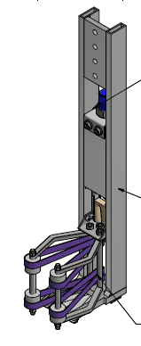

pneumatic cylinder

aluminum frame

rubber bands

*Fig. 2: First active harvesting tool*

During the previous project AmLight a harvesting tool had been developed which did the cutting and gripping passive just by using the linear speed of the vehicle. As this was not providing reliable harvesting results the GARotics approach was an **active harvesting tool**.

Figure 2 on the right shows a drawing of the cutting and gripping device which is being activate by a pneumatically cylinder once it has reached the position of harvesting. The tool has a wide opening angle to tolerate a lateral positioning error.

A simultaneously cutting and gripping is performed using one actuator. As the gripping claws are made of rubber bands, high differences in asparagus diameters as well as varying friction conditions by different ambient conditions are tolerated.

As part of **Task 2** the above explained technological solutions have been discussed with robotic experts from RIF Pisa during demonstration of the AmLight prototype at their facilities.

**Task 3** had the objective of intensive testing of implemented technological solutions. This was done in three steps. First at lab-scale in order to statistically verify whether or not the developments show to the potential of functionality. Secondly on an artificial dam to which real asparagus stalks were fitted. These tests were done partly inside of STRAUSS facilities and partly outside in front of STRAUSS facilities to also have the influence of ambient light. Finally the harvesting machine was sent to partner CWS in UK for field tests. A short video sequence of the tests can be watched on the GARotics website or by a click on the following link: <http://www.amlight.eu/garotics.php>.

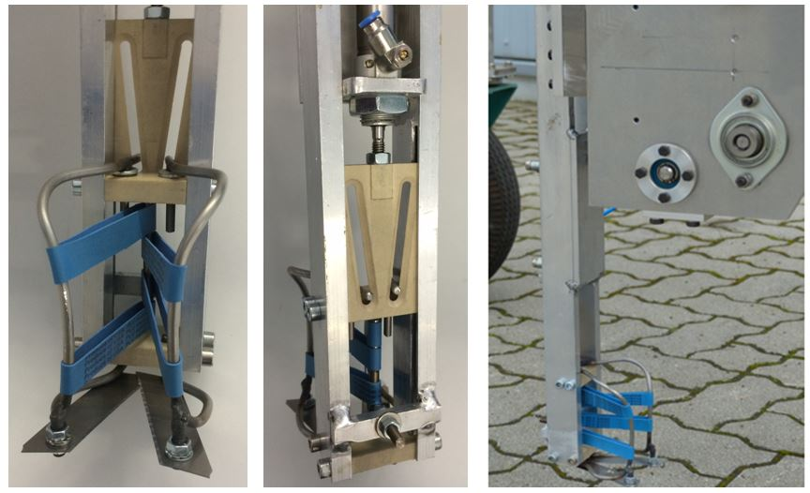

After the first two testing steps, the harvesting tool was redesigned to enable a faster positioning. Hence the tool weight has been reduced by e.g. integration of functions. Furthermore to prevent a collateral damage, the tool outer dimensions were reduced, Fig. 3.

Fig. 3: Second active harvesting tool

In order to compensate for lateral drifting of the machine, updated asparagus positions are regularly sent to the harvesting tools. However, the camera cannot reliably track asparagus stalks beyond the first tool, as afterwards the view is partially blocked. The lack of reliable drifting compensation led to a poor performance of the second tool (25 % success rate), compared to the first tool (90 % success rate).

Therefore a novel drifting compensation algorithm was developed for the second tool, which was based on the position of still visible stalks. The algorithm tracks visible asparagus stalks and based on their position change with respect to the camera, it can estimate the linear and angular velocity of the harvesting machine. Using these two estimated parameters, as well as the last known position of an asparagus stalk that is no longer visible, its current position can be estimated until it reaches the harvesting position and its tracking is no longer required.

Using this novel algorithm, the harvesting success rate could be increased from about 25 % to about 85 % for the second tool, while the success rate of the first tool was throughout the tests around 90 %.

The average velocity of the asparagus harvesting machine was 0.2 m/s. An average mechanical harvesting cycle took about two seconds, which means that once a harvesting process started, the tool was blocked for about 0.4 m. This means that having two tools, an average of 5 asparagus   
plants/meter could be harvested.

b)

a)

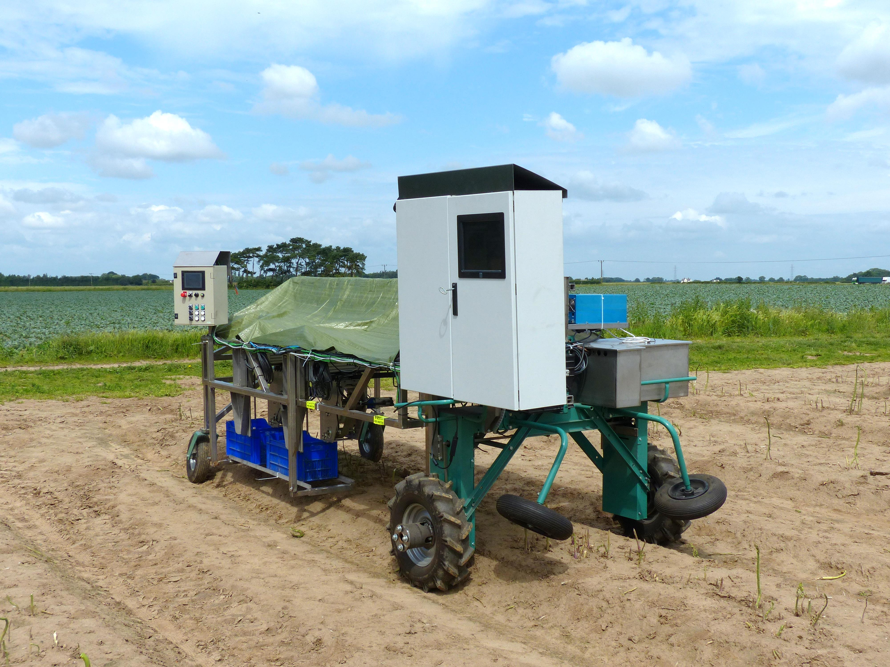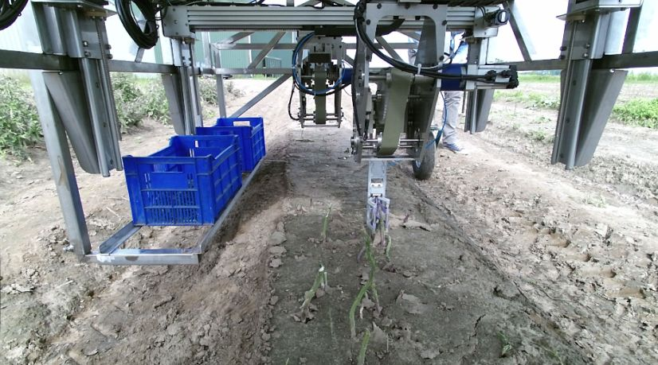

Fig. 4. The robotic harvester driving over an asparagus dam (a);  
the asparagus process as seen by the on-board camera, the storage box on the side of the machine (b).

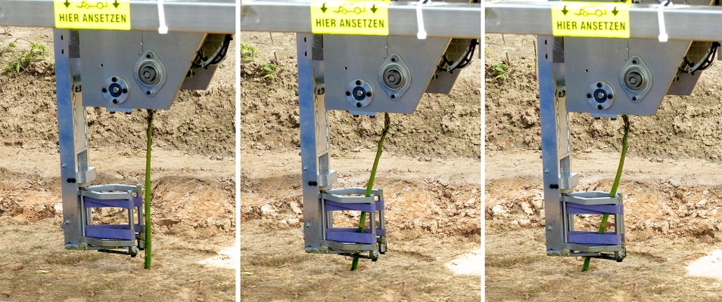

Fig. 5: Illustration of a part of the harvesting process, asparagus stalk approaching and grabbing by one of the harvesting tools

**Section 2.2: Scientific and technological achievements**

The main achievements of the GARotics experiment are listed in the table below:

|  |  |  |  |
| --- | --- | --- | --- |
| **Issue** | **Status at start of GARotics** | **GARotics objectives** | **Achieved at the end of Garotics** |
| Asparagus detection success | < 70% | 98% | 100%  During latest test on the artificial dam and during field tests no detection failures were observed |
| Precision of harvesting position | ± 3 cm | ± 1 cm | Less than  ± 1 cm  Due to the tracking the precision remains the same until the actual moment of harvesting |
| Harvesting success of detected stalks | Close to zero under real conditions | 95% | > 90%  For the first harvesting tool, as the tracking only reached the first tool;  Ca. 50%  Tracking still needed improvements after field tests for the redundant harvesting tool |
| Asparagus grading | Not existing | planned | Functional for two classes |
| Harvesting forecast | Not existing | Planned | Functional |
| Operation of redundant harvesting system | Not existing | planned | The second harvesting tool has been implemented to the control program. |
| TRL | 5 - Technology validated in relevant environment | Not determined | 7 - System prototype demonstration in operational environment |
| Harvesting tool cutting and gripping reliability (due to mechanics) | ≤60% | 95 % | Depending on the tracking (see above) |

A demonstration of the AmLight prototype to RIF in Pisa took place on the 15th of October 2015. The feedback from RIF experts during discussions after the demonstration were valuable to the experiment especially with respect to the robotic harvesting arm and the approach of active cutting and gripping.

**Section 2.3: Socio-economic achievements**

Three impact KPIs have been formulated for this experiment:

1. Competitive production costs – which can be calculated by harvested stalks per operator in a given time. However, due to a growing lack of seasonal workers and increasing labor cost for them, automatic harvesting will lead to competitive production costs immediately, once the system reaches TRL 9.
2. Increasing competitiveness of European machine manufacturers. According to EUROSTAT[1] the total area in Europe used for asparagus cultivation in 2015 sums up to 54.000 ha of which half is used for green asparagus. Only in these countries more than **5.000 farmers cultivate fields bigger than 5 hectare**. As each of these farmers is a potential user of an automatic harvesting system the theoretical market for machines, spare parts and maintenance contracts is huge.
3. Scalability of results. GARotics had the aim to proof the functionality of a ‘one-dam’ harvesting system. For commercial use this seems inadequate and a scale up of the system into a multi-dam harvester is indispensable after the end of the experiment.

In any case, all of the above named aspects will only generate a positive socio-economic impact, the work of AmLight and GARotics can be continued until the system reaches TRL 9.

**Section 2.4: Dissemination activities**

The results of the GARotics experiment have been disseminated in several ways. A complete and detailed explanation of dissemination activities has been reported through the MMR-document. Therefore following only a short summary:

Partner of GARotics were presented their results in two exhibition (i) iROS, 2015 in Hamburg and (ii) AUTOMATICA 2016 in Munich.

Furthermore GARotics was presented during three conferences (i) Kompetenznetzwerk Mechatronik, 2015 in Buxtehude, (ii) 6. Bremer Mechatronik-Tag, 2016 in Bremen and (iii) 38th Colloquium of automation in Bremen.

Also a number of publications and colloquia have been initiated, mainly by members of UniHB.

All events have been accompanied by flyers, posters, and/or PowerPoint presentations as well as the project video. Last but not least has the former AmLight website been extended for the publication of GARotics results: <http://www.amlight.eu/garotics.php>.

**Section 3: Resource usage summary**

|  |  |  |  |
| --- | --- | --- | --- |
| **Category** | **STRAUSS** | **CWS** | **UNIHB** |
| Personnel costs | 69.278,57 € | 15.773,81 € | ? |
| Travel/Shipment costs | ?? | ?? | ? |
| Overhead costs | ?? | ?? | ? |
| Equipment/Consumables | ?? | ?? | ? |
| **Total** |  |  |  |

**Section 4: Deviations and mitigation**

Two deviations may be named here:

1. A third robotic arm has not been installed to the machine. The consortium decided not to have the third robotic arm installed before the tracking of asparagus stalks was fully functional for the second arm. This, however, was only achieved right at the end of the experiment.
2. The second visit to RIF was canceled. Reason being that test on artificial dams in Germany as well as the field test in UK lasted to the very end of the asparagus season. Additional field tests in Italy, as originally planned, could therefore not take place.

**Section 5: Future work**

Developments within GARotics took the harvesting machine from TRL 5 to TRL 7 which can be considered as great success. However, commercial use and benefit will only materialize once the machine developments take another step to TRL 9. In order to achieve that, GARotics partners decided to apply for an FTI (fast track to innovation) project which has the aim to push prototype developments into the market. A proposal has been submitted to the EC by the middle of October 2016.

**Section 6: Lessons learned (optional)**

Maybe completed later…

* Tell us what lessons did you learn during the project? How it should have been done the different way by you, E++ management or EC.

1. <http://appsso.eurostat.ec.europa.eu/nui/submitViewTableAction.do>