**Directions**

**Hotel Costa Azul**

Avenida Gabriel Roca, 7

07014 Palma de Mallorca, Spain

Tel.: +34 971 731 940

Info@hotelcostaazul.es

**Getting from Palma Airport to Costa Azul Hotel**

The transfer from Palma Airport to Costa Azul Hotel can be done by urban bus no. 1: the bus stops right in front of the **hotel on the Seafront** (Passeig Maritim). The stop is actually called “Passeig Maritim 2” and it´s the one after Es Jonguet.

If you decide to hire a car, doing the transfer from Son Sant Joan Airport-Costa Azul Hotel is very simple: you have to **get onto the motorway** as soon as you leave the airport terminal, following signs for "Passeig Marítim de Palma", and continue without turning off. The road will bring you all the way to the hotel facing Palma Bay.

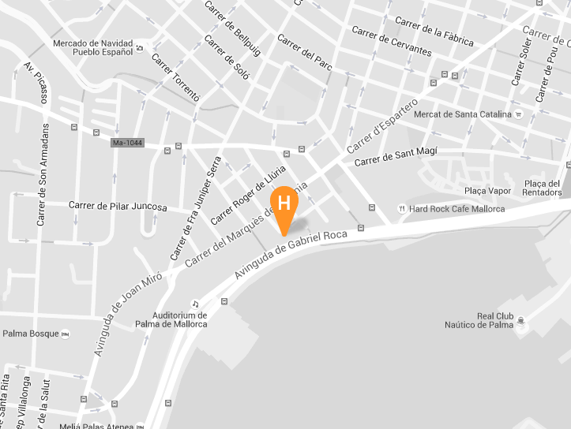

**Hotels close to Hotel Costa Azul**

|  |  |  |
| --- | --- | --- |
| **Hotel Mirador \*\*\*\***  Paseo Maritimo, 10, 07014 Palma, Spain  Tel.:[+34 971 73 20 46](javascript:void(0))  http://www.hotelmirador.es/en/  **Tryp Palma Bellver \*\*\*\***  Paseo Maritimo, 11, 07014 Palma, Spain  Tel.: [+34 902 14 44 40](javascript:void(0))  http://www.melia.com/de/hotels/spanien/mallorca/tryp-palma-bellver-hotel/index.html  **Hotel Armadams \*\*\*\***  Carrer Marqués de la Sènia, 34, 07014 Palma, Spain  Telefon: [+34 971 22 21 21](javascript:void(0))  http://www.hotelarmadams.com  **Melia Palas Atenea \*\*\*\***  Paseo Ingeniero Gabriel Roca, 29, 07014 Palma, Spain  Tel.: [+34 971 28 14 00](javascript:void(0))  http://www.melia.com/de/hotels/spanien/mallorca/melia-palas-atenea/index.htm  **Gran Melia Victoria \*\*\*\*\***  Avinguda de Joan Miró, 21, 07014 Palma, Spain  Tel. : [+34 902 14 44 40](javascript:void(0))  http://www.melia.com/en/hotels/spain/majorca/gran-melia-victoria/index.html  **Tryp Palma Bosque Hotel \*\*\*\***  Carrer Camilo José Cela, 5, 07014 Palma, Spain  Tel.: [+34 971 73 44 45](javascript:void(0))  http://www.melia.com/de/hotels/spanien/mallorca/tryp-palma-bosque-hotel/index.html  **Isla Mallorca & Spa \*\*\*\***  C/ Pilar Juncosa, 7, 07014 Palma, Spain  Tél.: [+34 971 28 12 00](javascript:void(0))  http://www.islamallorca.com |  | **Sercotel Hotel Zurbaran \*\*\***  Carrer de Josep Villalonga, 16, 07016 Palma  Tel. : [+34 971 22 17 71](javascript:void(0))  http://en.hotelzurbaranpalma.com/  **Hotel Hostal Cuba \*\*\*\***  Carrer de Sant Magí, 1, 07013 Palma, Tel. : [+34 971 45 22 37](javascript:void(0))  http://www.hotelhostalcuba.com |